|  |
| --- |
| Circle Language Spec: Events |

## Event Interface Reference

An event command will always implement an interface specified by the Event object. But if you want to express a command’s implementing the event interface without actually being tied to the event, it would look like this:

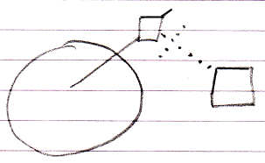

So the event connector is there and the command’s interface reference is tied to the event connector.